Fitness Plus Monthly
Volume 1, Issue 1 April 2021
What is Functional Fitness?
And why does it matter?
Melanie Meade, Certified Personal Trainer
Fitness Plus, LLC
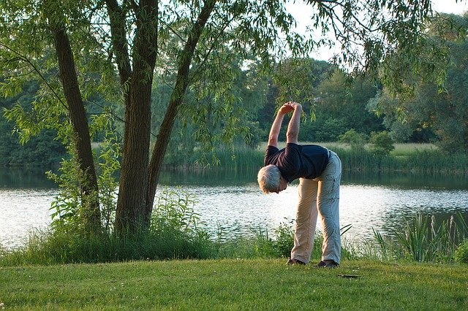
Do new fitness buzzwords drive you crazy? What is functional fitness? Why does it matter? How does it help us as we age? Typically, we like to read information that helps us with the aging process and ways in which we can improve workout routines. We also need to be sure we are incorporating all necessary elements of fitness to maintain proper flexibility and range of motion.
According to research presented by Choy, Brauer, & Nitz (2003), as women aged, there is an increased difficulty with single limb stance testing (SLST) for balance and as women entered their 70’s, this balance test could not be performed at all with the eyes closed. Additional concerns with muscle motor units and aging include an associated decline in muscle mass that is directly related to increased motor unit size and decreased firing rates (Ling, et al., 2009).
There is good news for those of us in the aging category. We can add muscle mass back with proper weight training routines. This does not mean we have
Fitness Plus, LLC
Where Your Health Matters
Melanie Meade, Certified Personal Trainer
Fitness Plus, LLC
Who We Are – Fitness Plus, LLC is your online resource for health and wellness coaching. Melanie Meade holds a masters in psychology, certifications with the American Council of Exercise in Personal Training and as a Behavioral Change Specialist. Fitness Plus, LLC provides a safe, virtual workout option for ladies age 40 to 65 who want to improve their health or to ensure they are leading a healthy life. Call us today at (910)795-6060 to set up your free health assessment. You may also email us at fitnessplus20@gmail.com.
to lift heavy weights every day to get results. We can also work on range of motion and with consistency, commitment, and focus, we can regain range of motion. This is, of course, assuming there are no injury-related concerns that would inhibit range of motion.
The most notable difference in training load guidelines
to lift heavy weights every day to get results. We can also work on range of motion and with consistency, commitment, and focus, we can regain range of motion. This is, of course, assuming there are no injury-related concerns that would inhibit range of motion.
The most notable difference in training load guidelines for women over 40 is greater volume. Research has shown that middle-aged women benefit more from higher-volume training programs than from lower-volume, high-intensity programs. When Burrup et al. (2018) examined the resistance training habits of 109 women over 40, results showed that for each day per week of strength training, body fat decreased by 1.3 percentage points and muscle mass increased by 656 grams. The findings indicated that the more days women devoted to resistance training, the lower their body fat and the higher their fat-free mass tended to be—even after accounting for differences in age, energy and protein consumption.
The research presented by Burrup et al. (2018) indicates that while estrogen plays a role in muscle tissue composition in women over 40, the results listed above indicate that even with the transition into menopause, women can build muscle with a devoted resistance training program. It is also important to remember that muscle memory plays a role in fitness. In other words, if your muscles remember a routine you practiced at a younger age, your body will adapt so that the body is exerting the least amount of effort to perform the exercise. Ladies, we have to mix it up and change how we exercise as well as how we perform resistance and weight training.
So, the overall message in this article is that we have to work the areas of our bodies that are neglected due to prolonged sitting with an office job, or with increasing inactivity as we get older. At www.fitnessplusleland.com , there are articles in the blog section discussing the benefits of housework, gardening and walking. So, as we age, we can truly get better with planning, goal setting, and keeping our bodies guessing a little on which exercises and which methods of training we are going to use.

References
Burrup, R., et al. 2018. Strength training and body composition in middle-age women. The Journal of Sports Medicine and Physical Fitness, 58 (1–2), 82–91.
Choy, N.L., Brauer, S., & Nitz, J. 2003. Changes in postural stability in women aged 20 to 80 years. The Journals of Gerontology: Series A, 58 (6), M525–30.
Ling, S.M., et al. 2009. Age-associated changes in motor unit physiology: Observations from the Baltimore Longitudinal Study of Aging. Archives of Physical Medicine and Rehabilitation, 90 (7), 1237–40.
EXERCISE AND MENTAL HEALTH
A deeper look at the relationship between exercise and mental health.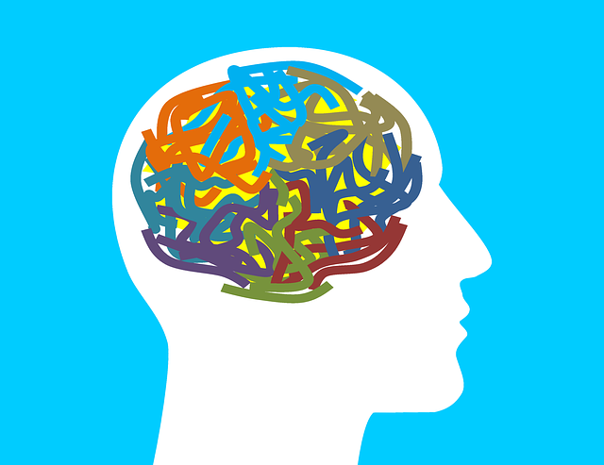
Findings from a large research study give greater insight into the exercise-mental health connection.
Do you or someone you love struggle with mental illness? The good news is that exercise can help. For starters, active people are nearly 45% less likely to have depressive symptoms than inactive people (Booth, Roberts & Laye 2012).
But a deeper look at the relationship between exercise and mental health raises complicated questions: How do factors such as frequency, duration and intensity of exercise relate to mental health? Are all types of exercise equally effective and beneficial for mental health?
Len Kravitz, PhD, program coordinator and professor of exercise science at the University of New Mexico, helps answer these questions with date from an important study on the topic.

continued on page 2

Inside This Issue
1 | Fitness Plus, LLC – Where Your Health Matters
1 | What is Functional Fitness?
2-3 | Exercise and Mental Health
continued on page 2
continued from page 1

continued from page 2

Mental Health: Gathering the Data
In the study, researchers examined data from more than 1.2 million U.S. adults who answered the Centers for Disease Control and Prevention’s Behavioral Risk Factor Surveillance System survey (Chekroud et al. 2018). To identify people dealing with mental health issues, the survey included this question: “Has a doctor, nurse, or other health professional ever told you that you have a depressive disorder, including depression, major depression, dysthymia, or minor depression?”
Respondents who said yes were asked: “Now thinking about your mental health, which includes stress, depression and problems with emotions, for how many days during the past 30 days was your mental health not good?”
The Link Between Exercise and Mental Health
The survey then asked, “During the past month, other than your regular job, did you participate in any physical activities or exercises such as running, calisthenics, golf, gardening or walking for exercise?” A yes response prompted this follow-up: “What type of physical activity or exercise did you spend the most time doing during the past month?”
The researchers identified 75 types of exercise which they grouped into eight categories to help the participants specify their physical activities: walking, popular sports, cycling, aerobic or gym workouts, running or jogging, recreational, household, and winter or water sports. Survey respondents reported the number of times per week or month they did each type of exercise and the length of a typical session in minutes or hours.

Study Results
Using a variety of complex statistical measures, the researchers broke new ground in clarifying several questions regarding exercise and mental health. The following question-and-answer format summarizes their findings.
1. How effective is exercise in managing mental health problems?
An analysis of 852,068 adults (out of 1.2 million surveyed) associated exercisers with 43.2% fewer self-reported mental health burdens per month than nonexercisers. The study observed this relationship across all ages, racial groups and household income levels.
2. Are all types of exercise associated with improved mental health?
Yes. Doing any type of exercise is associated with fewer mental health burdens compared with not exercising. In the study, the strongest connections were for popular sports (22.3% fewer), cycling (21.6% fewer), and aerobic and gym exercises (20.1% fewer). Further analysis conducted after the main study found that mindful exercises such as yoga and tai chi were associated with a 22.9% reduction in mental health burdens.
3. Is there an optimal exercise session duration for improving mental health burdens?
Yes. Exercise sessions lasting between 30 and 60 minutes correlated with the fewest mental health burdens—45 minutes produced the best effect consistently across all exercise types. Sessions longer than 90 minutes proved less helpful. Indeed, exercising for more than 3 hours per session was associated with greater mental health burdens than not exercising at all.
4. Is there an optimal exercise frequency for reducing mental health burdens?
Yes. Survey respondents who exercised 3–5 times a week had fewer mental health burdens than those who exercised less than 3 times or more than 5. This pattern persisted across all exercise types for light, moderate and vigorous intensities.
5. Is any specific exercise intensity associated with more favorable decreases in mental health burdens?
continued from page 3
Yes. The study found that vigorous exercise was linked to better mental health outcomes than either light or moderate exercise.
IDEA Fitness Journal SPRINT – April 2021
References
Booth, F.W., Roberts, C.K. & Laye, M.L. 2012. Lack of exercise is a major cause of chronic diseases. Comprehensive Physiology, 2 (2), 1143–211.
Chekroud, S.R., et al. 2018. Association between physical exercise and mental health in 1.2 million individuals in the USA between 2011 and 2015: A cross-sectional study. Lancet Psychiatry, 5 (9), 739–46.

